The **DUAL table** is a special **one-row, one-column table** present by default in Oracle and other database installations.

In Oracle, the table has a single **VARCHAR2(1**) column called **DUMMY** that has a value of ‘X’.

It is suitable for use in selecting a **pseudo column** such as SYSDATE, USER, etc .

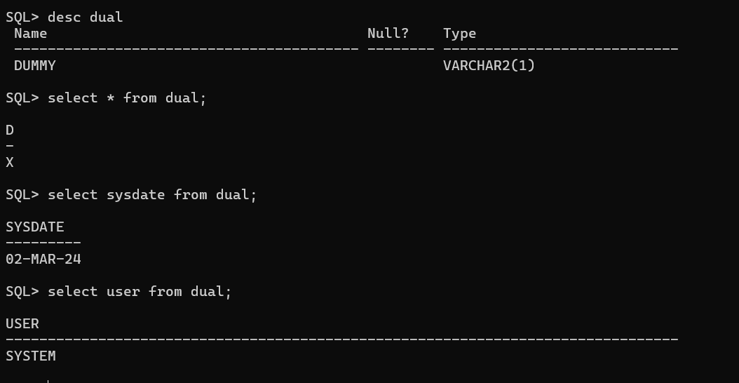

DUAL is in the schema of the user SYS but is accessible by the name DUAL to all users.

It has one column, DUMMY, defined to be VARCHAR2(1), and contains one row with a value X.

Selecting from the DUAL table is useful for computing a constant expression with the SELECT statement.

1. **Perform the following queries using DUAL:**
2. Display the current DATE and TIME.
3. Multiply 2 by 2 .
4. Find the absolute value of -15
5. Calculate the square root of 5.
6. Round off 15.19 to one decimal point:
7. Display the name " IVAN BAYROSS" in LOWERCASE.
8. Display the name " IVAN BAYROSS" in UPPERCASE.
9. Add 5 months to the present date and print the output.
10. Display the number of months between ‘02-JAN-01' and '02-JUL-01'
11. Print the system date in the particular format ‘DD/MMIYYYY'